Section 1   
**Questions 1-5**  
*Complete the notes below.*  
*Write****NO MORE THAN TWO WORDS AND/OR A NUMBER****for each answer.*

***Transport from Bayswater***

*Destination: Harbour City  
• Express train leaves at****1****• Nearest station is****2****• Number 706 bus goes to****3****• Number****4****bus goes to station  
• Earlier bus leaves at****5***

**Questions 6–10**  
*Complete the table below.*  
*Write****NO MORE THAN ONE WORD AND/OR A NUMBER****for each answer.*

| **Transport** | **Cash fare** | **Card fare** |
| --- | --- | --- |
| Bus | **6** $ | $1.50 |
| Train (peak) | $10 | $10 |
| Train(off-peak) – before 5 pm or after **7** pm | $10 | **8** $ |
| **9**  ferry | $4.50 | – |
| Tourist ferry (**10** ) | $35 | – |
| Tourist ferry (whole day) | $65 | – |

Section 1:

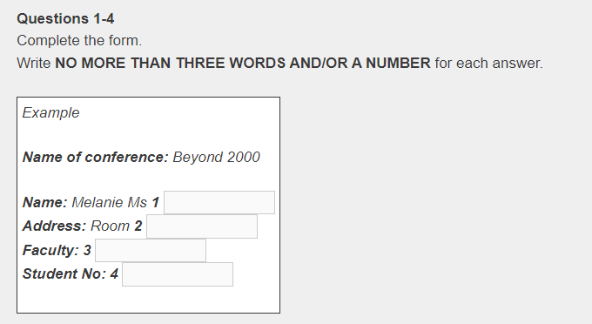

**Questions 5-10**  
Choose the correct answer **A-C**

**5** Registration for:  
**A** Half day  
**B** Full day  
**C** Full conference

**6** Accommodation required:  
**A** Share room/share bathroom  
**B** Own room/share bathroom  
**C** Own room with bathroom

**7** Meals required:  
**A** Breakfast  
**B** Lunch  
**C** Dinner

**8** Friday SIGs:  
**A** Computers in Education  
**B** Teaching Reading  
**C** The Gifted Child

**9** Saturday SIGs:  
**A** Cultural Differences  
**B** Music in the Curriculum  
**C** Gender Issues

**10** Method of payment:  
**A** Credit card  
**B** Cheque  
**C** Cash

**Questions 1-6**

Complete the form below.  
Write ***NO MORE THAN TWO WORDS AND/OR A NUMBER*** for each answer.

***EXPENSES CLAIM INFORMATION – GB AIRLINES*** *Customer name: Mr****1****Date of Departure:****2****2016  
Flight Number: GB1011  
Flight: From****3****to London Heathrow, UK  
Departure Time:****4****p.m.  
Expenses Claimed:****5****Hotel, 73 euros  
Taxis,****6****.*

**Questions 7-10**  
Complete the sentences below with ***NO MORE THAN TWO WORDS AND/OR A NUMBER***.

**7** The customer had the  option for his previous flight.  
**8** There are three meal options without meat: vegetarian, vegan, and  .  
**9** The vegan option doesn’t contain any  , eggs, fowl, or honey.  
**10** The meal option for the customer’s flight to Kiev must be changed  before the departure time.